**How COVID-19 has affected campus life in Korea?**

* Meeting and making new friends have been tougher than ever at a time when the pandemic has forced students to socially distance from each other
* Enter semesters at home sitting in front of the computer attending online lectures via Zoom/WebEx

**How are students and professors/teachers affected by COVID-19?**

Student

* "It's been a year and half since I entered college, but I barely know my fellow students. I've hardly had any chances to meet them in person, let alone hang out with them." (Jeong, 2021)
* "Communication with professors was highly limited during online lectures even when the classes were conducted in real-time. Asking questions and receiving feedback would have been much easier in regular in-person classes." (Seo, 2021)

Teacher/Professor

* “University-level online classes in Korea pose a number of challenges in terms of the network infrastructure and the lack of preparation.” (Kim, 2021)

Results of survey from 5 states across 26 districts covering 1,522 schools. (Hindustan Times, 2020)

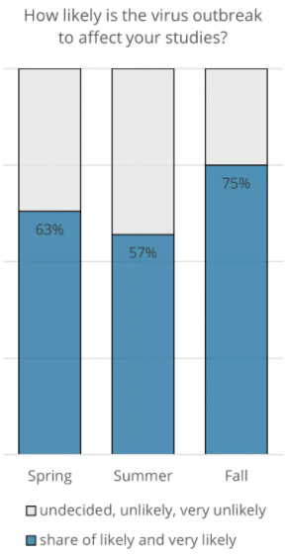

Results of survey from students. (Spring: 881 responses, Summer: 682 responses, Fall: 889 responses)

(Studyportals, 2020)

**Zoom vs WebEx vs Google Meet**

|  |  |  |  |  |
| --- | --- | --- | --- | --- |
|  | Cost | Participants | Conferencing Features | Web Features |
| Zoom | Free~$19.99/mth + | <500 | HD video and voice, screen sharing, whiteboarding | Private & group chats, MP4 or M4A local recording, host controls, Chrome & Outlook plug-ins |
| WebEx | Free~$26.95/mth + | <500 | HD video, screen sharing, whiteboarding | Multimedia content sharing, local recording, host controls toll-free dial-in |
| Google Meet | Free~$18/mth + | <250 | Screen sharing, video and audio preview screen, live captioning during meetings, whiteboarding | Private & group chats, multimedia content sharing |

**AR applications/platforms for studying**

1. Quiver

The application has a set of coloring pages that make cells pop off the page.

Quiver lets students go beyond the pictures in their textbooks to interact with three-dimensional figures.

“I tried to actually move the AR view around but it went away.” (Ratings: 2/5) (Spencer, 2020)

Cons: Students cannot design or use their own coloring sheets, categories are relatively limited, and content/quizzes can't be differentiated.



1. Blippar

Interactive content that brings the two-dimensional presentation to life.

Transform a child's reading experience by pushing him or her to think more deeply and explore a topic in a new way.

“Cool concept, but it doesn't work.” (Ratings: 1/5) (Jocelynn, 2021)

“Doesn't even give you feedback after scanning to let you know if scanning worked or not.” (Ratings: 1/5) (Arun, 2021)

